TAMK VR PROJECT

Team 4  
 Y-KAMPUS

Tatu Kankaanpää

Jaakko Myllymäki

Pyry Takkunen

Project report

December 2017

SISÄLLYS

1 INTRODUCTION 3

2 METHODS 4

2.1 Scanning with Matterport 4

2.2 3D Work in Blender 4

2.3 Development in Unity 5

3 RESULTS 6

4 DISCUSSION 7

ANNEX 8

Annex 1. Project window view 8

Annex 2. Player perspective from Y-Kampus stage 9

Annex 3. A close-up displaying the level of detail in the Matterport scan 10

# INTRODUCTION

This project was a pilot for upcoming 3D scanning courses planned by TAMK. Our assignment was to make a digital version of C1 (also known as Y-Kampus) and make a safety-themed VR application using that digital space.

The project started by getting introduced to the Matterport camera and its user interface. After the introduction and finding a right timeframe when no people were around, a full Matterport scan of Y-Kampus was done. The scan was then uploaded to a Matterport cloud from which a 3D model file was downloaded and imported into Unity.

On the Unity side, fire effects, lighting and highlights were added in addition to a basic VR locomotion functionality. The fire effects were not only a way to make the application into an intense emotional experience but also a fitting (and surprisingly efficient) method of concealing badly digitalized Matterport data. The angle we took as a team was a focus on the audiovisual, emotional experience more than any of the high-level interactive functionalities that other teams brought to the table. No point in inventing the wheel twice, so why not make a balloon?

# METHODS

We used the Matterport camera for scanning the space and to generate the actual 3D model. All of the visual customization work, such as trimming and smoothing, was done in Blender. Interactive and visual elements were added in Unity.

## Scanning with Matterport

All the scanning was done with Matterport 3D camera. Since none of us had used Matterport before, we needed to learn the basics and familiarize ourselves with the device. With the guidance from Juuso Huhtiniemi, we were able to get grasp of it. After few test scans, we felt that we were ready for the actual scan.

Our target was to scan the Y-Kampus and create 3D model from it. The real challenge with that space was that there are massive windows covering most of the wall area. Windows can be reflective and/or transparent. Reflectiveness and transparency are massive problems in 3D scanning. Luckily Matterport’s Capture App has a tool to mark windows (and mirrors also), so that the camera could deal with those issues.

Another major problem was the number of tables and chairs in the C1-space. We needed to organize the tables and chairs before scanning the area, so that cameras scanning path was clear. The main section of Y-Kampus (the “stage area”) had enough space to cover for hours, so instead of scanning the entire continuous glass maze that Y-Kampus is, we took the biggest chunk of it and ran with it.

After the scan was completed, it was time to upload it to Matterport cloud. When the server finishes processing the .obj file in Matterport Cloud, it is available for previewing and for downloading. Depending on the size of a scan it could take anywhere from 2 to 24 hours. Ours was available the next morning.

## 3D Work in Blender

Some of the more damaged and molten-looking parts of the scan (that we did not cover with fire effects) were re-done in Blender. Some smoothing and visual cleanup was also done, but some improved models were also not used as the original “burnt” once were considered as looking more like the fiery scene we were making. Mostly the project consists of the original scan and effects put on top of it. The path markers (basically just thick triangles) were also done in 3ds Max. Overall, the project reached acceptable visual quality without much 3D modeling thanks to our flame effect trickery, and good results are the best reason to avoid unnecessary labor.

## Development in Unity

Once the OBJ was downloadable from the Matterport site, it was imported into a Unity project, its scale and rotation corrected and lit up in a way to make it look like an inferno with Unity’s point light system. When flame effects were put on top of every corrupted/bad-looking/molten part of the scan, a satisfactory fire scene was already there to be experienced.

In order to make the experience an interactive VR simulation, virtual reality functionality and support needed to be added. SteamVR plugin for Unity was the first step into implementing HTC Vive support. After that and a few tries of making a pointer-based locomotion system, it was deemed unnecessary to put any more hours into tackling a technical problem that someone else had already solved and put the solution for out there for free, so some of the original work was overwritten in favor of a Unity asset called as VRTK. Taking a peek under its hood, its teleportation system was detachable as a sole component and implemented into our project. We ended up offering a teleport locomotion on both hand controllers (an arc and a straight line), as there might be differences in preferences and, in some cases, only one controller in use.

One of the important focal points of this project (as discussed with TAMK’s safety personnel) was fire safery. Our technical approach to this was paths comprised of glowing triangles that lead the way to the nearest fire exit in a pulsating fashion. For this purpose, a scalable pulsation script was made. The script can be assigned any number of objects in a list, and it will go through them (in this case, every triangle) and scaling each one larger in its turn, giving off the illusion of a bigger triangle “traveling” towards the exit. The speed can also be manually set from Unity. Outside of the “intense audiovisual experience” goal of ours, this is the most practical technical solution that we brought to the bigger project continuum.

# RESULTS

The result of this project is a fully functional and emotionally interesting “version 0.1” take on TAMK’s fire safety simulation that has all the intended functionality listed in previous chapters. The clients (TAMK staff that tried it out) seemed satisfied and excited of the possibilities. It was suggested that we would show the Y-Kampus people how we set their everyday environment on fire.

The client will receive a playable EXE of the project that can be used as a VR simulation when the computer is connected to a headset and as a keyboard-and-mouse controlled application when no headset is available. A video for quick presentation purposes will also be delivered. As per the requirements of the client, TAMK staff will also get access to the GitHub repository of the project.

# DISCUSSION

The project succeeded well taking note on how short time was to make it happen. “Version 0.1” was what was asked, what we went for and what we succeeded in making.

If there is one thing that separates our end result from those of the other teams, it’s the way ours works as an emotional experience and makes use of Matterport’s flaws turning them into a strength; the visual corruption looks like stuff is burnt or molten, and that fit the fire theme perfectly. This trickery was easy to produce and is something that we definitely recommend as a solution if fire is an element that can be used. One should not also underestimate the power of lighting the scene correctly in order to get the desired mood.

Some important lessons were learnt in avoiding unnecessary visual corruption also. Y-Kampus as a space is a cluster… well, a cluster of a lot of chairs and other stuff scattered across a floor space. Matterport really doesn’t like that, so we ended up moving most of Y-Kampus’s chairs next to walls.

Framerate is an issue that needs to be taken into consideration. VR eats up a lot of computing power, so the lights and effects used (or the amount thereof) is good for demo purposes only. Some people can experience nausea from framerates like the one the demo right now has.

Should this project continue from the pilot phase to an actual production, the team has preliminary interest in continuing depending on the financial benefits and time given. Also, after this pilot phase, it would seem an unnecessary waste of resources to break the production into four separate teams, so what we would like to see is all the strengths and angles of the demo teams and their projects combined into something that has the good sides of everything cherry-picked.

ANNEX

Annex 1. Project window view

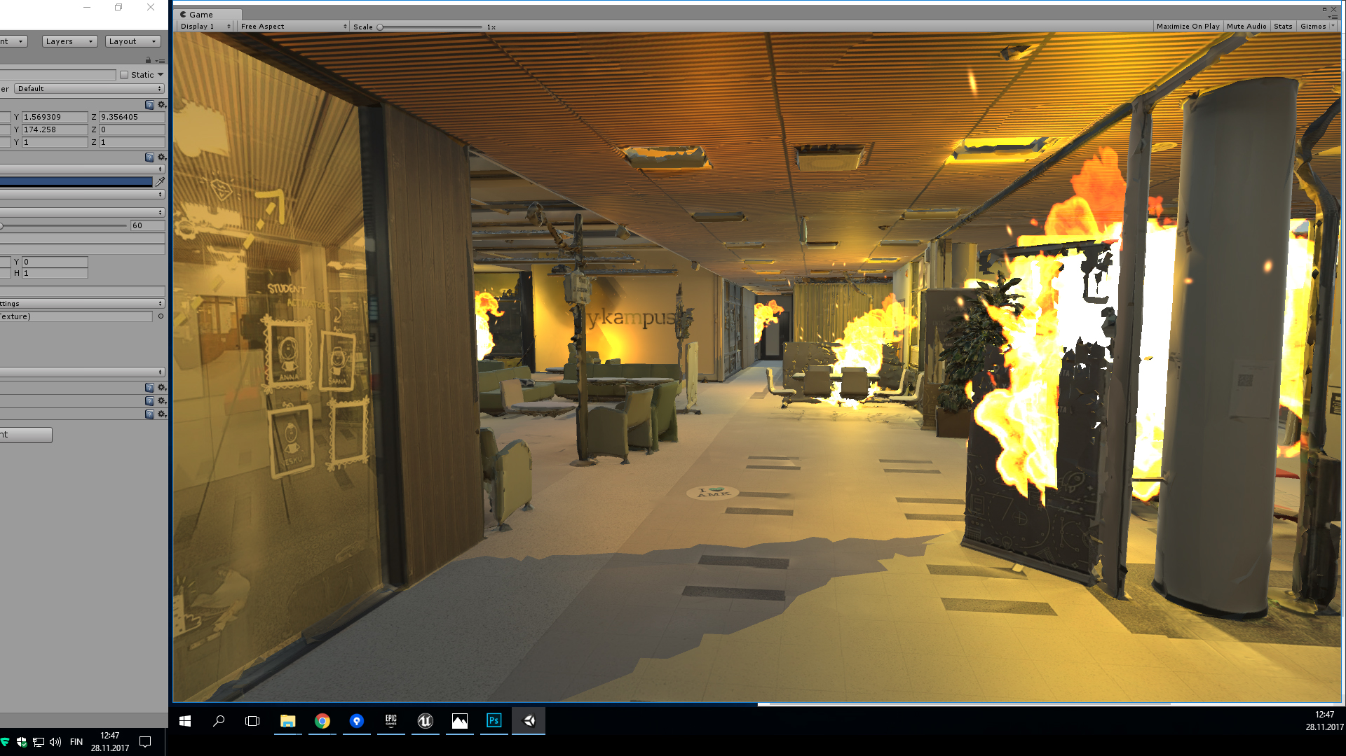

Annex 2. Player perspective from Y-Kampus stage

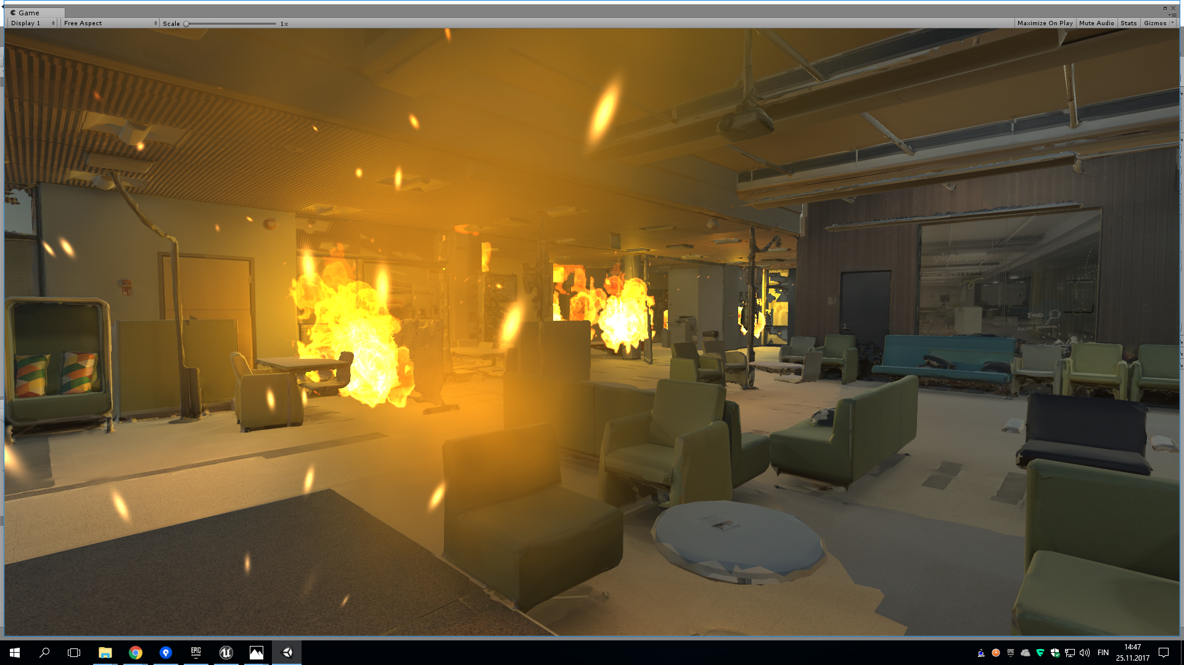

Annex 3. A close-up displaying the level of detail in the Matterport scan

